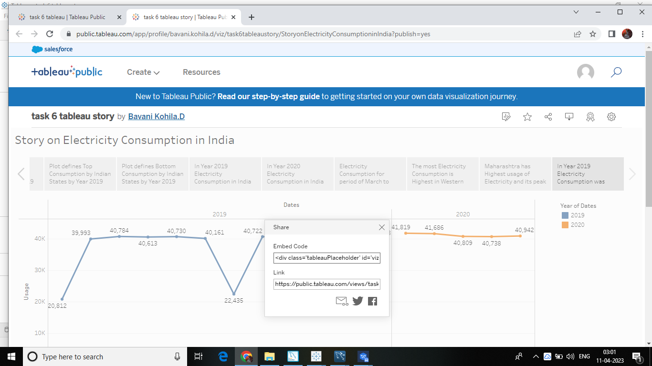

Dashboard public link

